Programming with Teens
A Super Smash Brothers Clone in the name of Code
Overview:
Students will be making a competitive, local, multiplayer game using a professional game engine : Unreal Engine. Through a distinct, tangible and measurable project completion : students will learn a vast array of programming techniques - level design, and user interface concepts behind the popular video games that they play.

The course will function as an 8 week dedicated course and could be considered a spiritual successor to the introductory workshops taught in November and December. This course will focus exclusively on project completion and prompt collaboration and teamwork.

The idea is to divide the students into two teams and divide and conquer a challenging, but familiar project. The game itself will be a “clone” of a popular video game that they are all familiar with “Super Smash Bros”. The idea is to blend a fun experience with serious programming concepts - to get them hooked and break the stigma that “code is boring”

Each team will compliment the strengths of its teammates. Team A will focus on the design of the characters, sound effects, particle systems and create the background worlds. Team B focus on the game mechanics and overall balance of the game. The intention of breaking into two - is to give students an outlet for their passions and progress in the hemisphere that they already excel in.

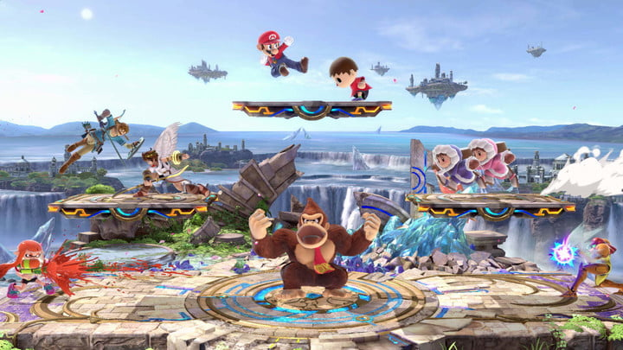
The bigger mission is to equip students with the necessary skill-set needed to compete in the future digital marketplace. The hope is grant students with a strong portfolio item that can be used as a resume builder for colleges, the workforce and beyond.
Timelapse
January - February 2019
8 weeks + 1 Grand Premiere

Part 1 : Introduction to code
Part 2 : Dissecting a template and remixing it your own
Part 3 : Team Split
Part 4 : Dev
Part 5 : Dev
Part 6 : Review and Playtest
Part 7 : Refine
Part 8 : Launch

Grand Premiere

By the end of session students will :
- Be able to distinguish complex computer code and write their own
- Learn how to strategically execute as a team
- Learn fundamental and transferable skills to be used in real life applications and the workplace

Logistics
- Students will showcase their creation at a grand premiere at Ives Square - open to the public, press, friends and family

Dates and Time
Tuesdays - 3:30-5:30pm

Tuesday, 1/8/9
Tuesday, 1/15/19
Tuesday, 1/22/19
Tuesday, 1/29/19

Tuesday, 2/5/19
Tuesday, 2/12/19
Tuesday, 2/19/19
Tuesday, 2/26/19

Grand Premiere - Friday March 8th, 2019

Labor, Staff and Cost

Proposed Cost
- 225 per course
- Cost Includes
  - Instructor Labor - 2 hour course
  - Student Lesson Plans
  - Pre-Visualization, Code Snippets and Take-home Materials

Support Staff
- Kyle Litscher
- Meghan Currey

Max Number of Participants
- 10

Further Reading:

Why Learn to Code - Research with Statistics weighing the benefits of learning how to code :
https://www.rasmussen.edu/degrees/technology/blog/why-learn-to-code/

For any and all inquiries please contact Alex Gonzalez via professorgonzz@gmail.com

References Available upon request.

